07/12/2025
Camille BORDES
Group dai
TP: Full Dev to Prod Pipeline Exercise
Machine Learning in Production

Data Base :

Dev :
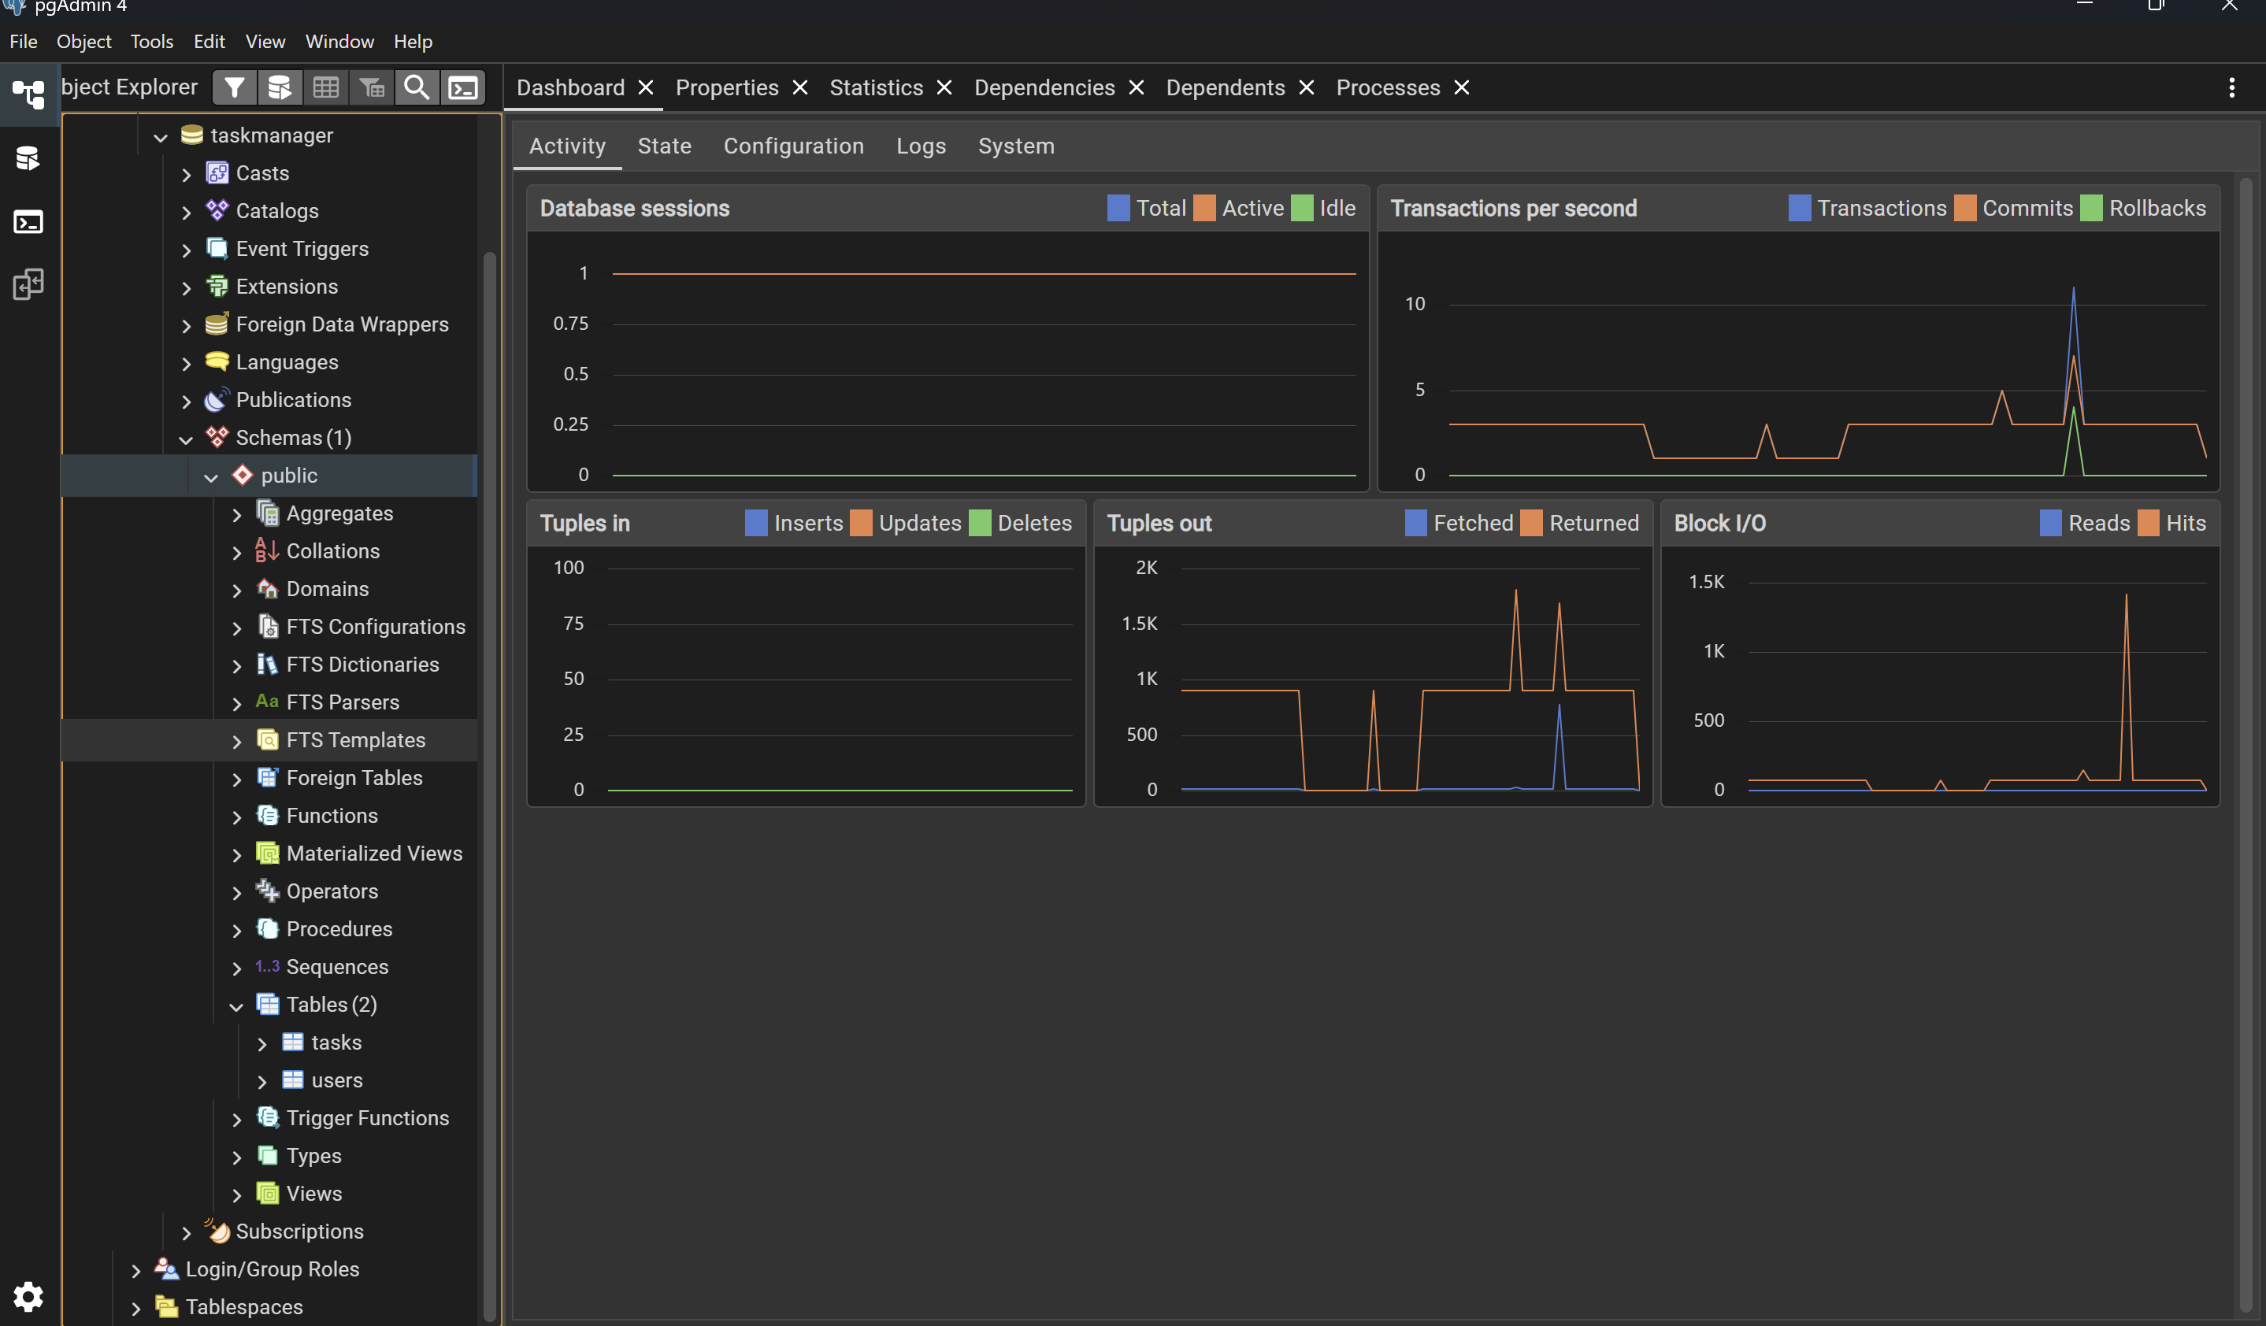

Prod :
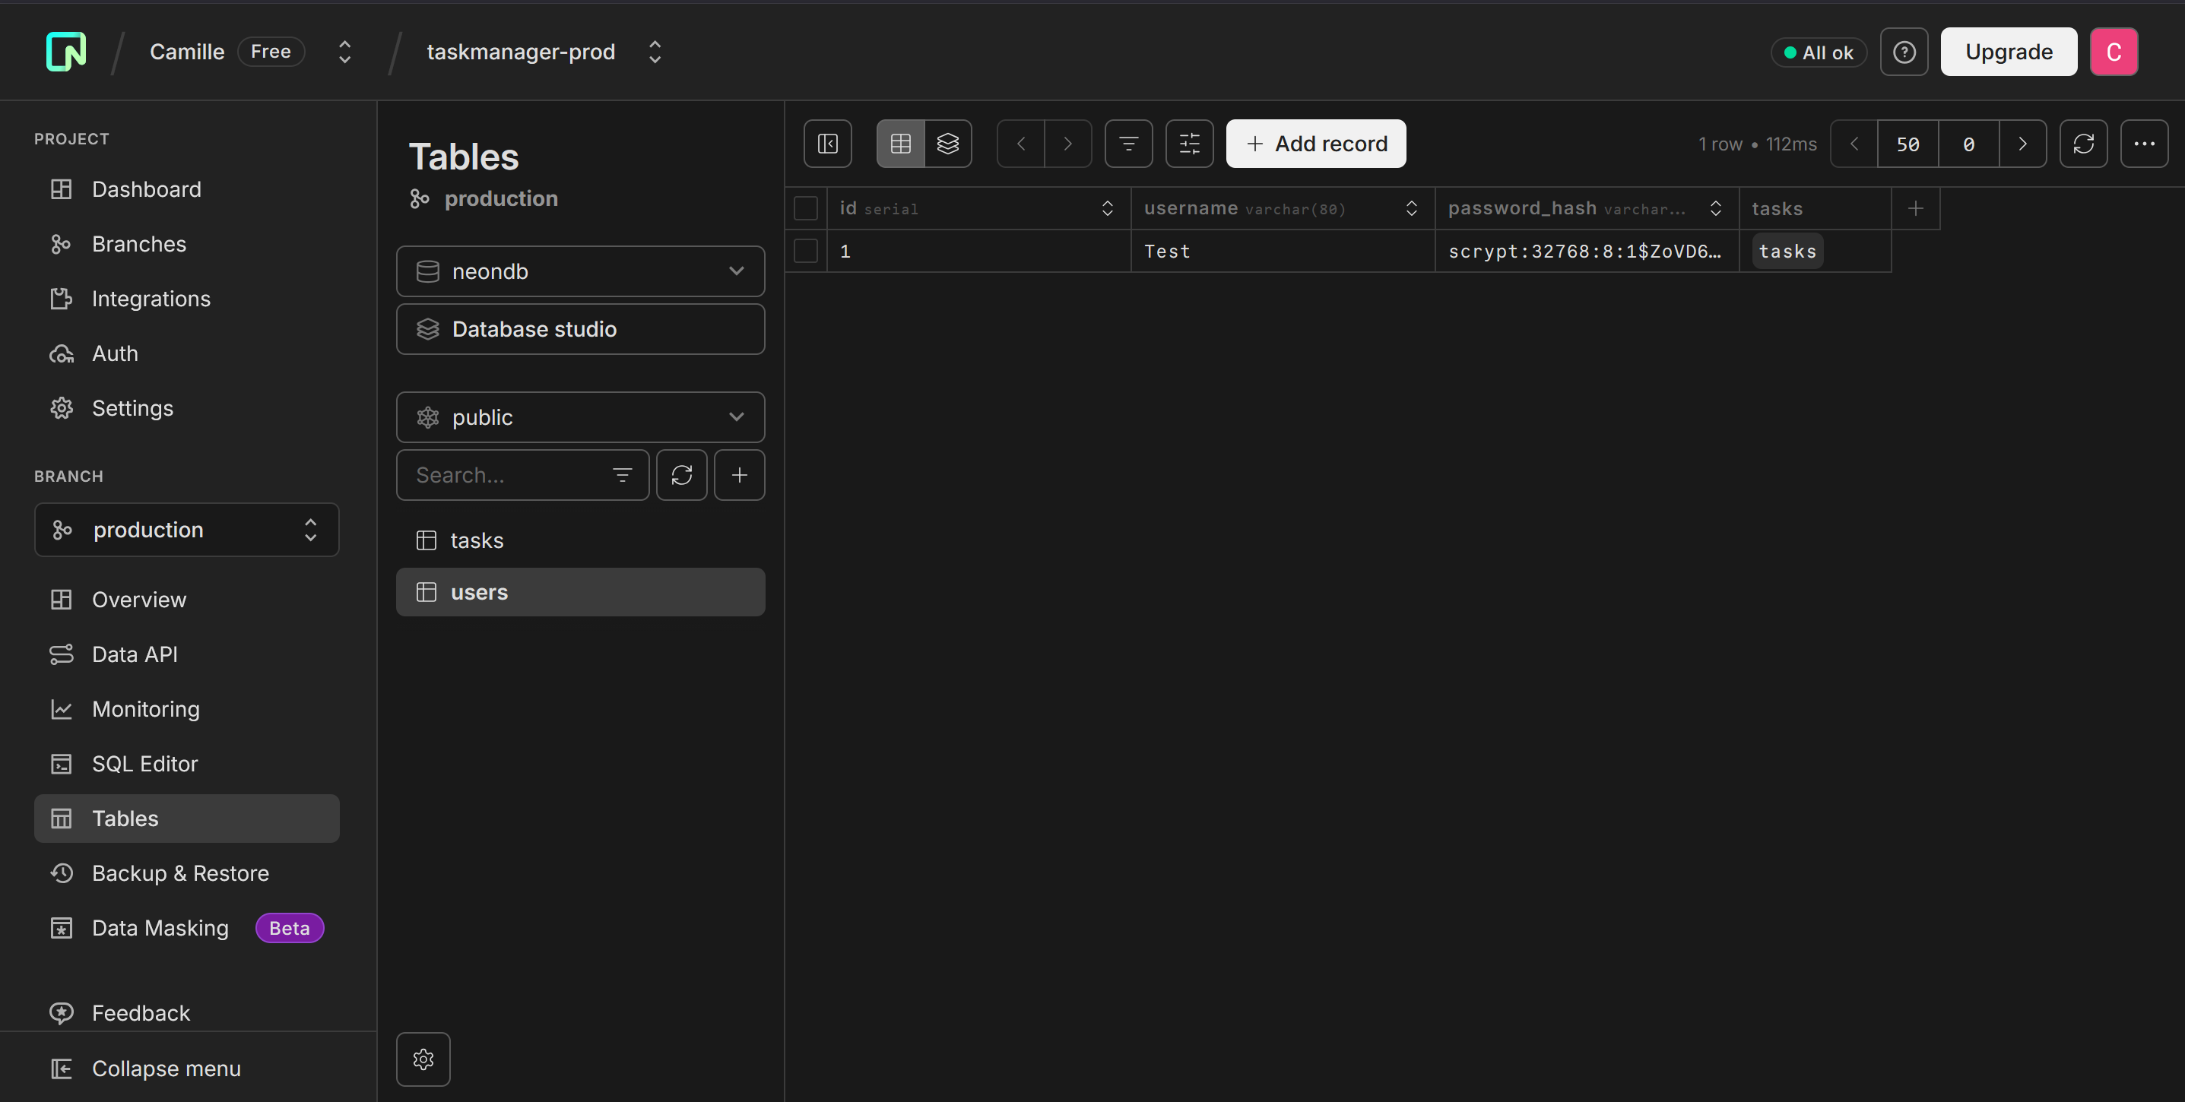

Docker :

Docker Desktop :

Docker Hub :
Link to the Docker Hub repo: https://hub.docker.com/r/camm1/taskmanager-prod
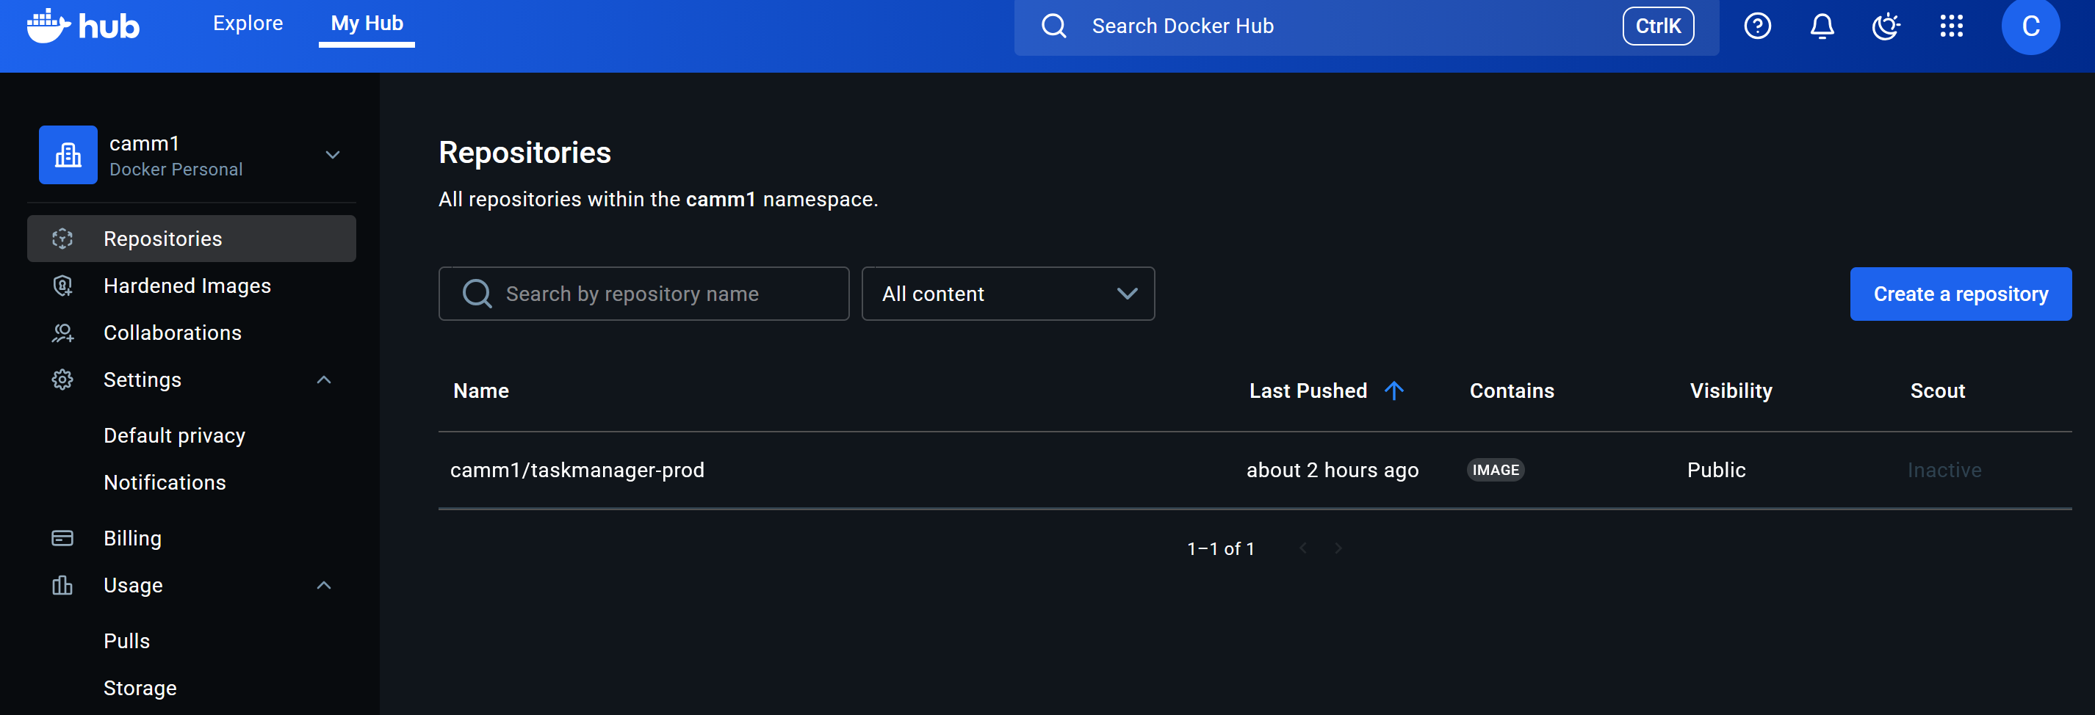

GitHub
Link to the GitHub repo: https://github.com/camm22/TP-Full-Dev-to-Prod-Pipeline-Exercise
